LAST DATE OF RECEIPTOF APPLICATION: 12.03.2018
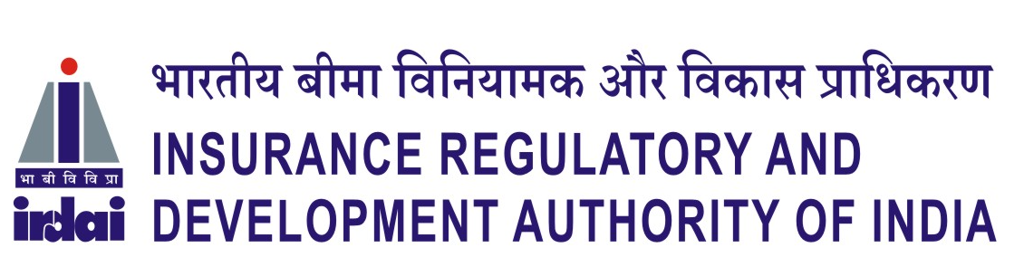
Survey No. 115/1, Financial District, Nanakramguda, Hyderabad - 500 032
APPLICATION FOR THE POST OF (____________________)
1. Name in full  ( In CAPITAL LETTERS ) |  |  |  |  |  | First Name
 |  |  |  |  |  | Middle Name
 |  |  |  |  |  | Surname
2. Gender  (✓) | Male |  |  |  |  |  |  |  |  |  | Please paste your  Passport Size  Photograph  in this box
2. Gender  (✓) | Female |  |  |  |  |  |  |  |  |  | Please paste your  Passport Size  Photograph  in this box
3. Date  of Birth | D | D | M |  | M |  | Y | Y | Y | Y | Please paste your  Passport Size  Photograph  in this box
Age: (as on 12.03.2018) |  |  | ……… years &…..… months |  |  |  |  |  |  |  | Please paste your  Passport Size  Photograph  in this box
4. Father’s / Husband’s Name :
5. Whether belonging to SC/OBC/PWD/UR-GenCategory:
6. Religion:
7. IRDAI employee (Yes or No):

8. Academic Qualifications:

Qualification | Main Subjects | Year of passing | Institute / University | Overall % of marks | Class/ Division
Post
Graduation
Graduation
Professional Qualification
(If any)
(Applicants may add extra rows to give full description)

9. Details of Experience (starting from the present employment)
Name and Address of the Employer | Designation | Scale (i.e. I, II, III, IV/V) | Job Profile | Period |  | Total Duration in  Years, Months
 |  |  |  | From  (DD-MM-YYYY) | To  (DD-MM-YYYY) | Total Duration in  Years, Months
(Applicants may add extra rows to give full description)

9.1 Total Experience (in years & months): ………………………………………………

10. Address for communication
Postal Address (in capital letters) | E-Mail
State | Mobile No.
Pin Code

11. Any other Information you would like to furnish:

DECLARATION

- I hereby declare that the all the statements made in this application are true, complete and correct to the best of my knowledge and belief.
- I declare that
- I have not been, at any time, convicted by a court in India for any offence involving moral turpitude.
- No proceedings in respect of an offence alleged to have been committed by me are pending before any court in India.
- No warrant or summons for the appearance, or a warrant for arresting me has been issued by a court and no order prohibiting me from departure from India has been issued by any court.
3. I understand that any incorrect information furnished by me is found to be false or that does not satisfy the eligibility criteria will lead to my disqualification from the selection process and my candidature/appointment is liable to be cancelled / terminated.
4. I agree and declare that my admission to the written examination and/or interview is strictly provisional. The mere fact that the call letter for written examination and/or interview has been issued to me does not imply that my candidature has been finally cleared by IRDAI and further it does not entitle me for appointment in IRDAI
5. I understand and agree that in case my candidature for the post applied for is cancelled by IRDAI I will not be entitled to apply for any post in IRDAI for the reason of false information given by me.

Date:(Signature of the Applicant)
Place:

Encl: Self attested copies of the following certificates/documents are enclosed:
- Date of birth
- Educational qualifications
- Marks sheets (from Graduation onwards)
- Experience certificate/s
- Professional qualifications
- Caste certificate, Disability certificate, etc. (where applicable)

